JG-KN95 防护口罩机

KN95 Protective mask machine

技术资料

Specification

·

Ⅰ、企业简介 company profiles

  - 公司概况 Company Overview
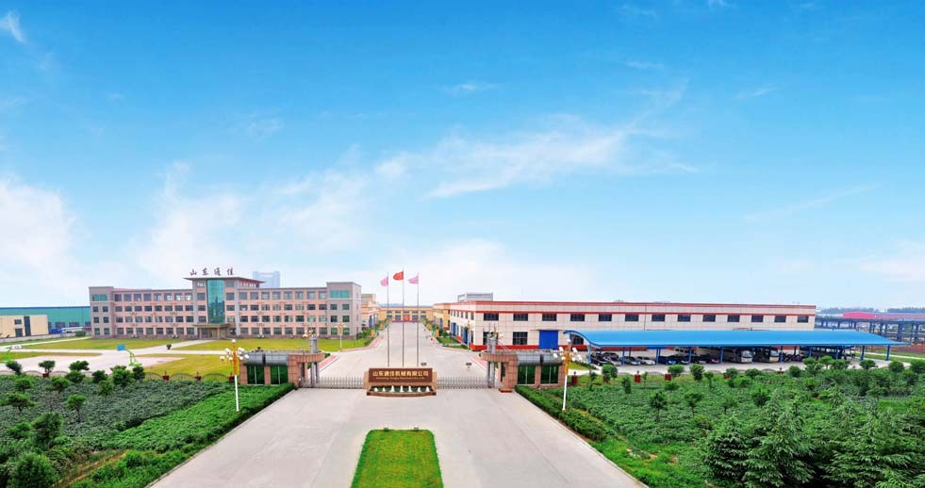

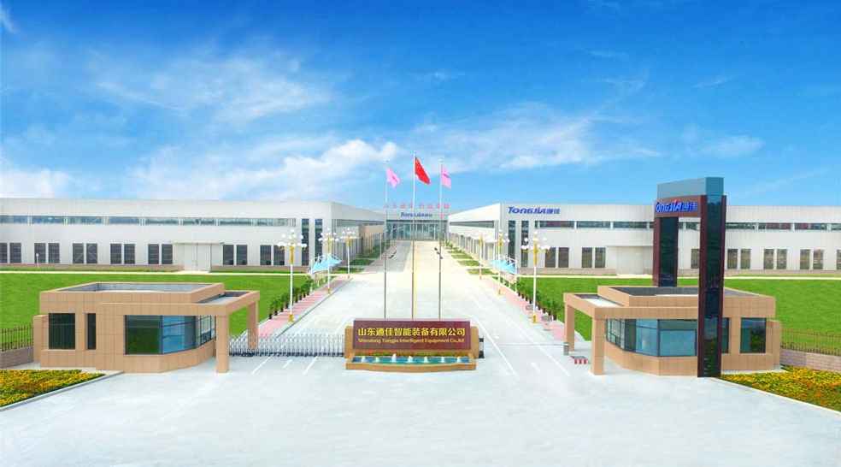

山东通佳机械有限公司 Shandong Tongjia Machinery Co., Ltd.

  - 公司及产品相关荣誉证书 Company and product honor certificates
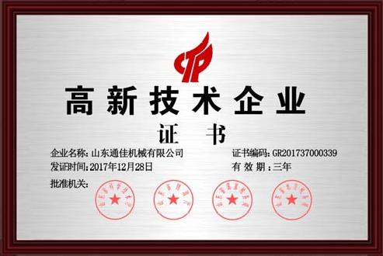
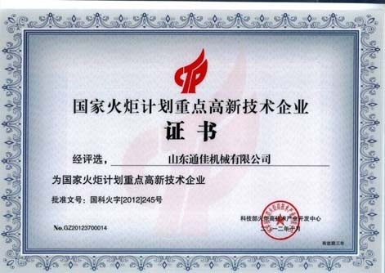

国家高新技术企业 国家火炬计划重点高新技术企业
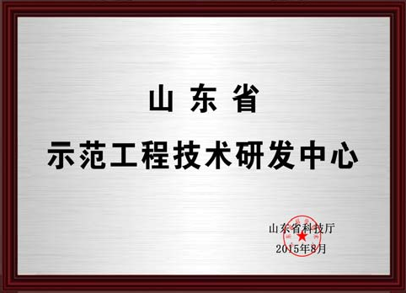

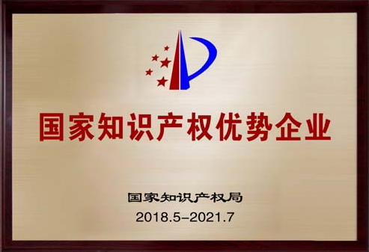
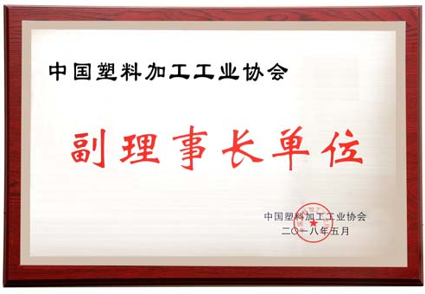
中国塑料机械工业协会副会长单位 山东省示范工程技术研发中心

国家知识产权优势企业 中国塑料加工工业协会副理事长单位

  - 通佳公司车间实景 Real scene of Tongjia company workshop

（金属加工车间 Metal processing workshop）
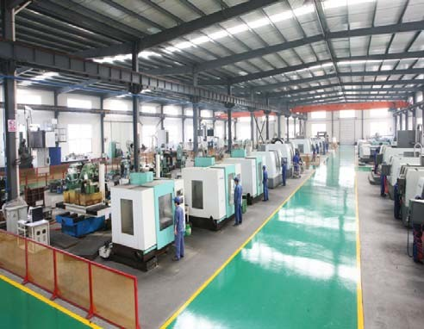
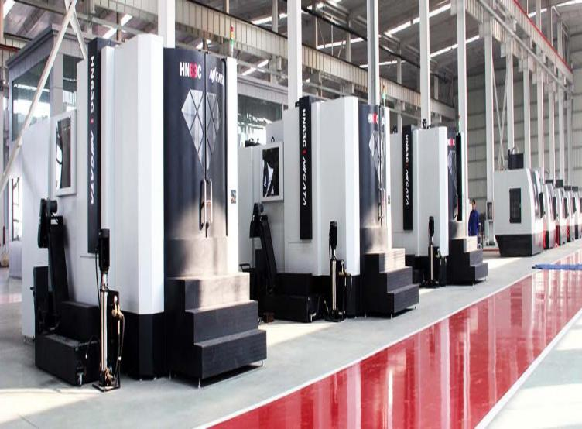
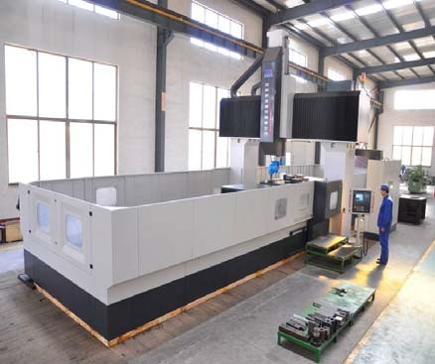
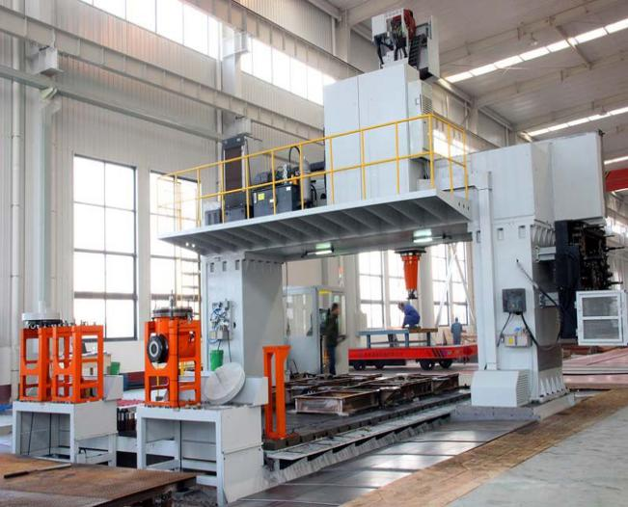

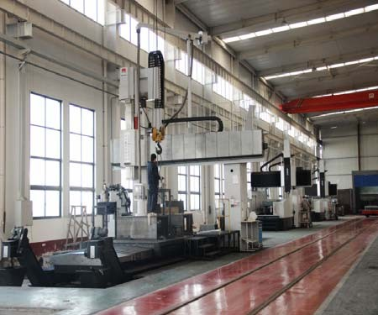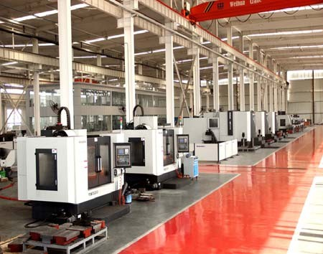

- Price list 价格单

No.  序号 | Name of Commodity  名称 | Model 型号 | Q’ty (set)  数量（台） | Amount  （金额￥）
 |  |  | FOB Qingdao Port of China In RMB FOB 中国青岛港
1 | Protective mask machine  防护口罩机 | JG-KN95 | 1 | 1,435,000
Total 合计 |  |  |  | 1,435,000,

Note:
  - The price is valid for one month. 价格有效期一个月。
  - Delivery time 交货期：35~40 days. 35~40 天

Termsof Payment 付款方式：
30% by T/T as down payment. After the examination of the goods pay 70% by T/T before picking up the goods. 30% TT 预付，70%TT 尾款发货前付清。

Shipping container 海运集装箱 20GP×1
  - Installation and commission 安装调试：
The seller will send engineers stay in 20 days for commissioning.
The relevant charges such as salary US$100/person/day,visa and round way air-tickets will be borne by Buyer.
卖方派工程师去买方工厂调试 20 天，买方需承担食宿、往返机票、签证及每人每天$100 工资。

Guarantee 质保期：
12 month, lifelong service for customer. 12 个月质保，终生服务。

Electricity unit 电器配置
Main motor BEIDE Brand (Siemens Standard Motors Ltd.)
主电机 西门子贝德
Main transducer Siemens or Danfoss Brand
主变频器 西门子或丹佛斯
Main low voltage electrical apparatus Schneider Brand
主低压电器 施耐德品牌
Main temperature controller meterOmRon or Fuji Brand
主温控仪 欧姆龙或富士
Voltage 380V 50HZ
电压 380V 50HZ

2020-3-24

第二部分 技术资料
Part II Specification
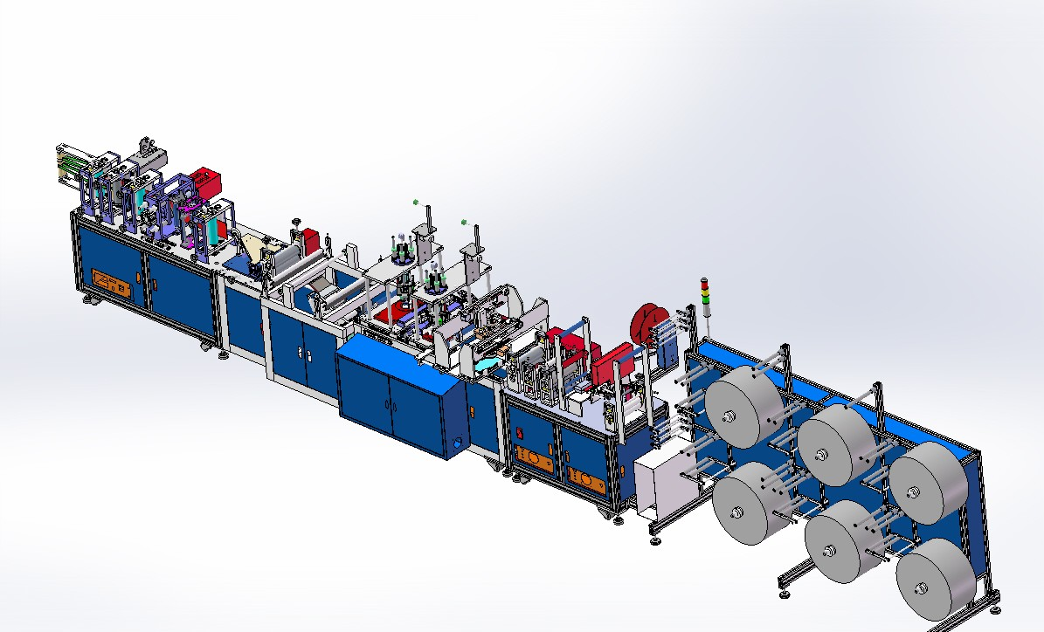

一 KN95 口罩生产线特点

    - Features of KN95 mask production line

KN95 口罩由 6 层专用过滤无防布构成，符合 NIOSH 标准过滤率达 95%，可以有效过滤某些微生物颗粒（入病毒、细菌等），避免飞沫交互感染，保护人体健康。
KN95 口罩生产线秉承“科技创造卓越”的企业理念，集数十年机械生产制造经验之精髓，采用最优化设计技术，全线采用自动控制系统，伺服追剪焊接，有效地将能耗降到最低、效率提高到较高水平。本生产线在国内具有领先地位，是目前最具有广阔前景的投资项目。
KN95 mask is composed of 6 layers of special filtering non-wowen, which meets the NIOSH standard filtration rate of 95%. It can effectively filter certain microbial particles (entering viruses, bacteria, etc.), avoid cross-infection of droplets and protect human health.
The KN95 mask production line adheres to the corporate philosophy of "technology creates excellence", integrates the essence of decades of machine manufacturing experience, uses optimized design technology, and uses automatic control systems across the entire line, servo tracking welding, effectively reducing energy consumption to a minimum. Increased efficiency to a higher level. This production line has a leading position in China and is currently the most promising investment project.

1、生产工艺说明

该生产线有 6 个布料盘和一个鼻梁条放卷盘，可以生产最多 6 层的 N95 口罩。每一放卷都有缺料报警与涨力调节，卷料层叠进入，同时放入鼻梁条，通过超声波焊接把多层布料焊接在一起，并压出各种花纹，然后冲出口罩阀孔，进行商标印刷，并自动焊接耳带，随后进行折叠、焊接、切型，最后成品入箱， 飞边收放。
      - Production process description

The production line has 6 cloth trays and a nasal bridge unwinding tray, which can produce up to 6 layers of N95 masks. Each unwinding has a lack of material alarm and tension adjustment. The rolls are stacked in, and at the same time they are placed in the bridge of the nose. Weld multiple layers of fabric together by ultrasonic welding, and press out various patterns, and then punch out the valve hole of the cover. Carry out trademark printing and automatically weld the earrings, then fold, weld, cut, and finally put the finished product into the box, and fold it away.
2、生产流程图

布料放入 → 入鼻梁 → 焊接压花 → 冲阀孔 → 牵引 → 印商标

→ 焊接耳带 → 折叠 → 焊接边缘 → 切型 → 收边 → 成品入箱

      - Production flow chart

Nowoven insertion → Nose bridge → Welding embossing → Punch valve hole → Traction → Printed trademark→ Welding ear bands → Folding → Welding edges → Cut-out → Close-up → Finished products in the box
3、机组整厂生产设备

The whole plant production equipment

1〉放卷机构（6 工位） 一套

1>Unwinding mechanism (6 stations) 1 set

2〉鼻梁条放卷机构 一套

2>Nose bridge strip unwinding mechanism 1 set 3〉鼻梁条校直机构 一套
3> Nose bridge straightening mechanism 1 set

4〉鼻梁条驱动、裁切机构 一套

4> Nose bridge driving and cutting mechanism 1 set

5〉鼻梁条放入机构 一套

5> Nose bridge strip placement mechanism 1 set 6〉花型焊接装置 一套
6>Flow welding device 1 set

7〉阀孔裁切机构 一套

7> Valve hole cutting mechanism 1 set

8〉牵引机构 一套

8> One set of traction mechanism 1 set

9〉印商标机构 二套
9 〉 Two sets of trademark agencies 2 sets
10〉自动焊接耳带机构 二套
10 〉 Two sets of automatic welding ear strap mechanism 2 sets 11〉焊接耳带自动伺服追剪机构 一套
11〉 A set of automatic servo shearing mechanism for welding ear band 1 set 12〉对折叠机构 一套
12 〉 One set of folding mechanism 1 set
13〉焊接边缘机构 一套
13 〉 Welding edge mechanism 1 set
14〉焊接边缘自动伺服追剪机构 一套
14〉 A set of automatic servo tracking shearing mechanism for welding edge 1 set 15〉切型机构 一套
15 〉 cutting mechanism 1 set
16〉快速输送机构 一套
16 〉 A set of fast conveying mechanism 1 set 17〉收边机构 一套
17 〉 A set of border collection agencies 1 set 18〉电器控制系统 一套
18 〉 Electrical control system 1 set

二、KN95 口罩生产线详细组成

Detailed composition of KN95 mask production line

1〉放卷机构 | 一套
1|>Unwinding system | 1set
放卷工位 | 6 套
Unwinding station | 6 sets
缺料报警检测 | 6 套
Out of material alarm detection | 6 sets
布料卷筒直径 | Φ60--Φ80
Nowoven roll diameter | Φ60--Φ80
料卷直径 | Φ600
Roll diameter | Φ600
料卷宽度 | 250mm
Roll width | 250mm
2〉鼻梁条放卷机构 | 一套
2> Nose bridge strip unwinding mechanism | 1 set
放卷工位 | 1 套
Unwinding station | 1 set
缺料报警检测 | 1 套
Out of material alarm detection | 1 set
布料卷筒直径 | Φ30—Φ50
Nowoven roll diameter | Φ30—Φ50
料卷直径 | Φ350
Roll diameter | Φ350
料卷宽度 | 1000mm
Roll width | 1000mm
3〉鼻梁条校直机构 | 一套
3> Nose bridge straightening mechanism | 1 set
校准个数 | 7 轮
Calibration number | 7 rounds
轮直径 | Φ22

Wheel diameter Φ22

4〉鼻梁条驱动、裁切机构 一套

4>Nose bridge driving and cutting mechanism 1 set

裁切形式 间歇碰轮

Cutting type intermittent touch wheel

动力机构 主轴传动

Power mechanism Spindle drive

5〉鼻梁条放入机构 一套

5>Nose bridge strip placement mechanism 1 set

放入形式 推板式

Insertion form push plate type

动力机构 主轴传动

Power mechanism Spindle drive

6〉花型焊接装置 一套

Pattern welding device 1 set

焊接方式 超声波

Welding method: Ultrasonic 1 set

焊接震子 20K

Welding Oscillator 20K 1 set

7〉阀孔裁切机构 一套

7> Valve hole cutting mechanism 1 set

裁切方式 超声波

Cutting method Ultrasound

裁切轮直径 Φ83

Cutting wheel diameter Φ83

8〉牵引机构 一套

8> One set of traction mechanism 1 set

牵引辊直径 Φ83mm

Traction roller diameter Φ83mm

动力机构 主轴传动

Power mechanism Spindle drive

9〉印商标机构 二套

Trademark Agency 2 sets

印刷形式 油墨

Printing type Ink

印刷动力 气动

Printing power pneumatic

10〉自动焊接耳带机构 二套10>Two sets of automatic welding ear band mechanism 焊接方式 超声波
Welding method Ultrasonic

焊接震子 20K

Welding Oscillator 20K

11〉焊接耳带自动伺服追剪机构 一套

11>A set of automatic servo shearing mechanism for welding ear band

动力机构 伺服

Power mechanism Servo

伺服功率 750W

Servo power 750W

12〉对折叠机构 一套

12>One set of folding mechanism 1 set

辊直径 Φ83mm

Roller diameter Φ83mm

动力机构 主轴传动

Power mechanism Spindle drive

13〉焊接边缘机构 一套

13> Welding edge mechanism 1 set

焊接方式 超声波

Welding method Ultrasonic

焊接震子 15K

Welding Oscillator 15K

动力 气动

Power Pneumatic

14〉焊接边缘自动伺服追剪机构 一套

14>A set of automatic servo tracking shearing mechanism for welding edge

动力机构 伺服

Power mechanism Servo

伺服功率 750W

Servo power 750W

15〉切型机构 一套

15>cutting mechanism 1 set

切辊直径 Φ83mm

Cutting roller diameter Φ83mm

动力机构 主轴传动

Power mechanism Spindle drive

16〉快速输送机构 一套

Fast conveying mechanism 1 set

输送形式 平带式

Conveying form 1 set

动力机构 主轴传动

Power mechanism Spindle drive 1 set

17〉收边机构 一套

17>A set of border collection agencies 1 set

收边辊直径 Φ60mm

Edge roller diameter Φ60mm

动力机构 主轴传动

Power mechanism Spindle drive

18〉电器控制系统 一套

Electrical control system 1 set

控制方式 界面操作

Control method interface operation

屏幕规格 7”

Screen size 7 ”

电源电压 220V

Power supply voltage 220V

主轴控制方式 伺服控制

Spindle control mode Servo control

伺服功率 1.5KW

Servo power 1.5KW

三、机组功耗

机组装机容量：约 15KW 220V 单相

因为超声波间歇工作，再者主机电机在正常生产后，不再全功率工作，所以该机组正常生产实际消耗功率约为总装机容量的 40％～60%。
- The unit power consumption

Machine assembly capacity: about 15KW 220V single phase

Because the ultrasonic works intermittently, and the main motor does not work at full power after normal production, the actual power consumed by the unit during normal production is about 40% to 60% of the total installed capacity.
四、安装与调试

1、机组应放置于平面良好处。

2、按生产线布置图放置各部分设备，校准机组中心线及水平。辅机之间的距离可根据车间场地情况适当调整。
3、机组电器须有良好接地保护。

4、就位完毕，再连接电、气管路。

5、检查各部件是否有松动、脱落现象。

6、检查各传动部件转动是否正常。

7、单独调试各部分设备，待运转均正常后再进入整机调试。

Installation and commissioning

- The unit should be placed in a good plane.

- Place each part of equipment according to the production line layout drawing, and calibrate the centerline and

level of the unit. The distance between auxiliary machines can be adjusted appropriately according to the situation of the workshop site.
- The unit's electrical equipment must be well grounded.

- After the installation is completed, connect the electric and gas pipelines.

- Check whether all parts are loose or falling off.

- Check whether the transmission parts rotate normally.

- Separately debug each part of the equipment, and then enter the whole machine debugging after the operation is normal.

注： 以上内容仅供参考，本公司保留改动权。如有改动，恕不通知。
Note: The above contents are for reference only, and the company reserves the right to change. Subject to change without notice.

